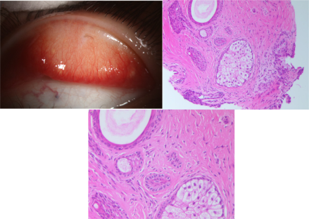

An otherwise healthy 9-year-old boy presented with irritation and tearing of the left eye for 6 months. There was no family history of asimilar disorder, and the patient had no medical history of any ocular surgery or trauma. Slit-lamp examination showed a single black hairlocated in the palpebral conjunctiva of the upper lid (A). The lesion, including the hair and a tarsal plate tissue, was completely removed.Histopathologic examination showed posterior ectopic cilia (B and C). Based on the provided images and clinical description please make an ophthalmic diagnosis for this patient. And output the diagnostic conclusions only.

**Posterior ectopic cilia**